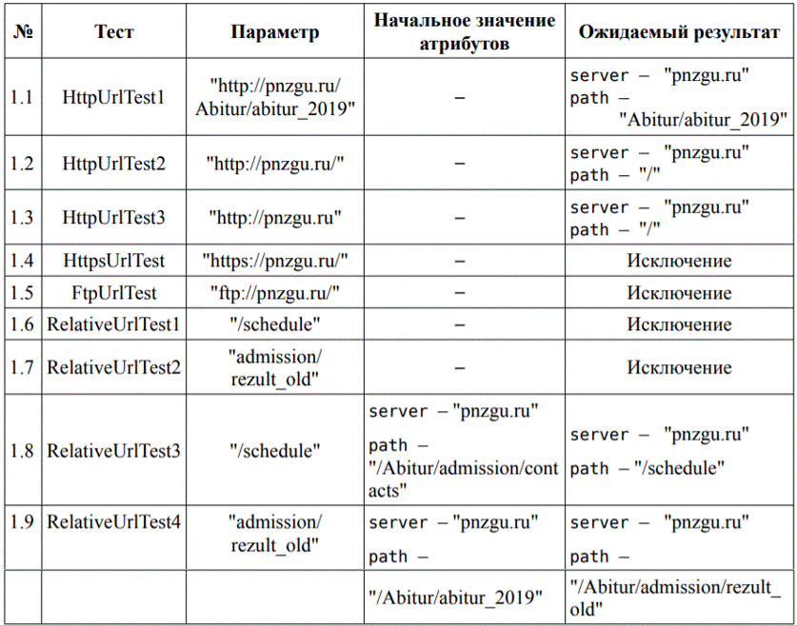
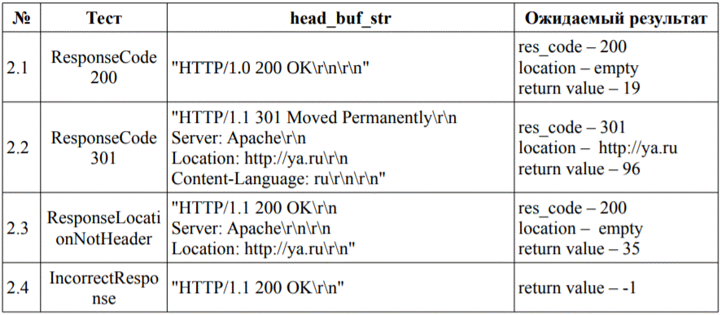

Модульный код
#include <UnitTest++/UnitTest++.h>
#include "../http_client/HTTPClient.h"
SUITE(SetUrlTest)
{
TEST(HttpUrlTest1)
{
HTTPClient hc;
hc.set_url("http://pnzgu.ru/Abitur/abitur_2019");
CHECK_EQUAL(hc.get_server(), "pnzgu.ru");
CHECK_EQUAL(hc.get_path(),"/Abitur/abitur_2019");
}
TEST(HttpUrlTest2)
{
HTTPClient hc;
hc.set_url("http://pnzgu.ru/");
CHECK_EQUAL(hc.get_server(), "pnzgu.ru");
CHECK_EQUAL(hc.get_path(), "/");
}
TEST(HttpUrlTest3)
{
HTTPClient hc;
hc.set_url("http://pnzgu.ru");
CHECK_EQUAL(hc.get_server(), "pnzgu.ru");
CHECK_EQUAL(hc.get_path(), "/");
}
TEST(HttpsUrlTest)
{
HTTPClient hc;
CHECK_THROW(hc.set_url("https://pnzgu.ru/"),Error);
}
TEST(FtpUrlTest)
{
HTTPClient hc;
CHECK_THROW(hc.set_url("ftp://pnzgu.ru/"),Error);
}
TEST(RelativeUrlTest1)
{
HTTPClient hc;
CHECK_THROW(hc.set_url("/schedule"), Error);
}
TEST(RelativeUrlTest2)
{
HTTPClient hc;
CHECK_THROW(hc.set_url("admission/rezult_old"),Error);
}
TEST(RelativeUrlTest3)
{
HTTPClient hc;
hc.set_server("pnzgu.ru");
hc.set_path("/Abitur/admission/contacts");
hc.set_url("/schedule");
CHECK_EQUAL(hc.get_server(), "pnzgu.ru");
CHECK_EQUAL(hc.get_path(), "/schedule");
}
TEST(RelativeUrlTest4)
{
HTTPClient hc;
hc.set_server("pnzgu.ru");
hc.set_path("/Abitur/abitur_2019");
hc.set_url("admission/rezult_old");
CHECK_EQUAL(hc.get_server(), "pnzgu.ru");
CHECK_EQUAL(hc.get_path(),"/Abitur/admission/rezult_old");
}
}

SUITE(ParseHeadersTest)
{
TEST(ResponseCode200)
{
int http_code;
std::string loc, http_str = "HTTP/1.0 200 OK\r\n\r\n";
int ret = HTTPClient::parse_headers(http_str,http_code, loc);
CHECK_EQUAL(ret, 19);
CHECK_EQUAL(http_code, 200);
CHECK(loc.empty());
}
TEST(ResponseCode301)
{
int http_code;
std::string loc, http_str = "HTTP/1.1 301 MovedPermanently\r\nServer: Apache\r\nLocation: http://ya.ru\r\nContent-Language: ru\r\n\r\n";
int ret = HTTPClient::parse_headers(http_str,http_code, loc);
CHECK_EQUAL(ret, 96);
CHECK_EQUAL(http_code, 301);
CHECK_EQUAL(loc, "http://ya.ru");
}
TEST(ResponseLocationNotHeader)
{
int http_code;
std::string loc, http_str = "HTTP/1.1 200 OK\r\nServer: Apache\r\n\r\nLocation: http://ya.ru\r\n";
int ret = HTTPClient::parse_headers(http_str,http_code, loc);
CHECK_EQUAL(ret, 35);
CHECK_EQUAL(http_code, 200);
CHECK(loc.empty());
}
TEST(IncorrectResponse)
{
int http_code;
std::string loc, http_str = "HTTP/1.1 200 OK\r\n";
int ret = HTTPClient::parse_headers(http_str,http_code, loc);
CHECK_EQUAL(ret, -1);
}
}
int main(int argc, char** argv)
{
return UnitTest::RunAllTests();
}

